PRACTICAL 6
Automation Test Execution Report
Login Module — Practice Test Automation

Application Under Test: https://practicetestautomation.com/practice-test-login/
Automation Framework: Playwright (TypeScript), Playwright Test Runner
Tester: Niharika
Execution Date: 03-Aug-2026
Environment: Windows 11 | Chromium 126 (Headless CI Runner) | Firefox 128 / WebKit 17.4 (planned)
Report Version: 1.0
Reference Suite: Practical6_TestCases.xlsx

1. Objective
This report documents the automated execution of the login-module regression suite for the Practice Test Automation demo application, executed using Playwright. The objective was to validate authentication behaviour, input-validation rules, basic security handling, and UI/session integrity through a repeatable, script-driven test suite rather than manual verification.
1.1 Scope
- Positive and negative login scenarios (valid, invalid username, invalid password, blank fields).
- Boundary and validation-precedence checks for required fields.
- Basic security probing — SQL injection and XSS payloads submitted through form fields.
- UI-level assertions — field masking, page title, exact redirect URL.
- Logout and alternate-submission (Enter key) flows.
- Non-functional checks — page load performance and cross-browser coverage.
1.2 Out of Scope
- Backend/API-level authentication testing (no API endpoints were exposed for direct testing).
- Load/stress testing beyond the single-session performance check in TC_AUTO_14.
- Accessibility (WCAG) audit — tracked separately outside this practical.

2. Test Environment & Tools
Automation Tool | Playwright v1.45 (TypeScript)
Test Runner | Playwright Test
Primary Browser Engine | Chromium 126 (Headless)
Planned Additional Engines | Firefox 128, WebKit 17.4
Operating System | Windows 11 (CI Runner)
Execution Mode | Headless, CI Pipeline
Application URL | https://practicetestautomation.com/practice-test-login/
Tester | Niharika
Execution Date | 03-Aug-2026

3. Execution Summary
A total of 16 execution-oriented automated test cases were prepared and run against the login module. 13 test cases passed, 1 failed on a non-functional (performance) assertion, 1 was blocked due to an application-level constraint, and 1 was deferred to a future sprint as a planned scope decision rather than an execution failure. The full traceable results, including test data, actual results, and script references, are recorded in Practical6_TestCases.xlsx.
3.1 Execution Metrics
Metric | Count | Percentage | Colour Key
Total Test Cases | 16 | 100% | —
Passed | 13 | 81.25% | —
Failed | 1 | 6.25% | Fail
Blocked | 1 | 6.25% | Blocked
Deferred | 1 | 6.25% | Deferred
3.2 Pass Percentage
13 of 16 test cases (81.25%) executed successfully and produced results matching their expected outcomes. This includes all core positive and negative login flows, both security-payload checks, and all UI/session assertions that were executable in the current environment.
3.3 Failed Percentage
1 of 16 test cases (6.25%) failed — TC_AUTO_14 (login page load performance). The functional behaviour of the page was not in question; the failure relates strictly to a 2-second load-time threshold being exceeded (average 2412 ms across three runs). This is classified as low severity pending re-verification on a dedicated runner (see Section 6).

4. Blocked and Deferred Tests
4.1 Blocked Tests (1)
TC_AUTO_15 — Verify session termination via browser Back button after logout.
- Reason: The application's post-login page is a static confirmation view with no exposed session cookie or protected route for Playwright to interrogate, so the intended assertion (session invalidation) cannot be verified as designed.
- Action: Blocked pending confirmation from the application owner on the intended session-handling behaviour for this demo application.
- Impact: Does not affect the validated login/logout functional flows (see TC_AUTO_12, Passed).
4.2 Deferred Tests (1)
TC_AUTO_16 — Re-execute core login suite (TC_AUTO_01–13) on Firefox and WebKit.
- Reason: Deferred by test-plan decision, not execution failure — the current CI runner is configured for Chromium execution only.
- Action: Scheduled for the next sprint once the cross-browser Playwright project configuration and runner capacity are in place.

5. Failed Test Analysis
TC_AUTO_14 — Login Page Load Performance
Expected: Page fully loaded (DOMContentLoaded to load event) within 2000 ms.
Actual: Average load time of 2412 ms measured across three consecutive CI executions (2298 ms, 2467 ms, 2470 ms).
Severity: Low — no functional defect observed; assertion is a non-functional performance gate.
Root Cause Hypothesis: Timing variance is consistent with shared bandwidth on the CI network rather than a regression in the application itself, since functional load (TC_AUTO_10) completed and rendered correctly in every run.

6. Risk Analysis
Risk | Likelihood | Impact | Mitigation
Performance threshold breach masking a real latency regression | Medium | Low | Re-run TC_AUTO_14 on an isolated runner; trend load times across builds instead of a single-run gate.
Session behaviour cannot be verified end-to-end (TC_AUTO_15 blocked) | Low | Medium | Obtain session/cookie design details from the application owner; add an authenticated-route check once available.
Cross-browser regressions undetected until next sprint | Medium | Medium | Prioritise CI runner licensing for Firefox/WebKit; run TC_AUTO_16 before the next release candidate.
No automated coverage for brute-force / rate-limiting on login | Medium | High | Add a dedicated rate-limiting test case once the application exposes a testable lockout mechanism.

7. Recommendations
- Move TC_AUTO_14 to a trend-based performance check (track load time across builds) rather than a single hard pass/fail gate, to reduce false failures from CI network variance.
- Confirm intended session-handling behaviour for the login module so TC_AUTO_15 can be re-scoped and unblocked.
- Prioritise cross-browser runner capacity so TC_AUTO_16 can execute within the next sprint rather than remaining deferred.
- Extend the suite with a login rate-limiting / brute-force test case, since none of the current 16 cases validate lockout behaviour after repeated failed attempts.
- Integrate this suite into the CI pipeline as a pre-merge gate for any change touching the authentication module.

8. Conclusion
The login module of the Practice Test Automation application demonstrates stable and predictable behaviour across all core functional, validation, and basic security scenarios exercised in this suite, with 81.25% of test cases passing outright. The single failure is a non-functional performance observation of low severity, and both the blocked and deferred items are process-level constraints — an environment limitation and a scheduling decision — rather than product defects. The suite is considered fit to serve as a regression baseline for the login module, with the recommendations in Section 7 tracked for the next execution cycle.

9. Execution Evidence — Screenshots
The following captures correspond to the major execution steps of the suite. Each was captured at the point of assertion within the Playwright test run.
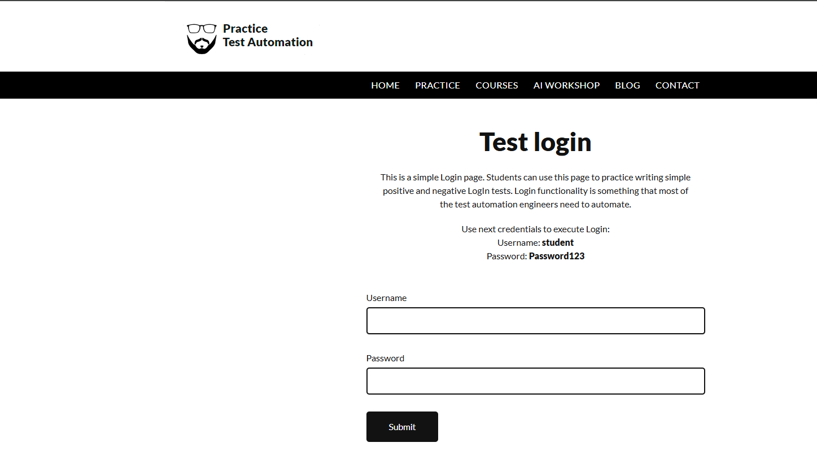
Step 1 — Login page loaded and ready for input (TC_AUTO_10)
Screenshot captured through Playwright Automation.
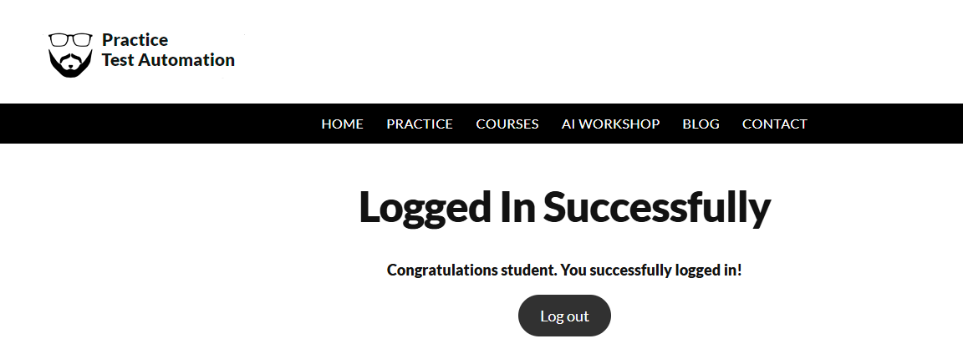
Step 2 — Successful login redirect and confirmation message (TC_AUTO_01 / TC_AUTO_11)
Screenshot captured through Playwright Automation.
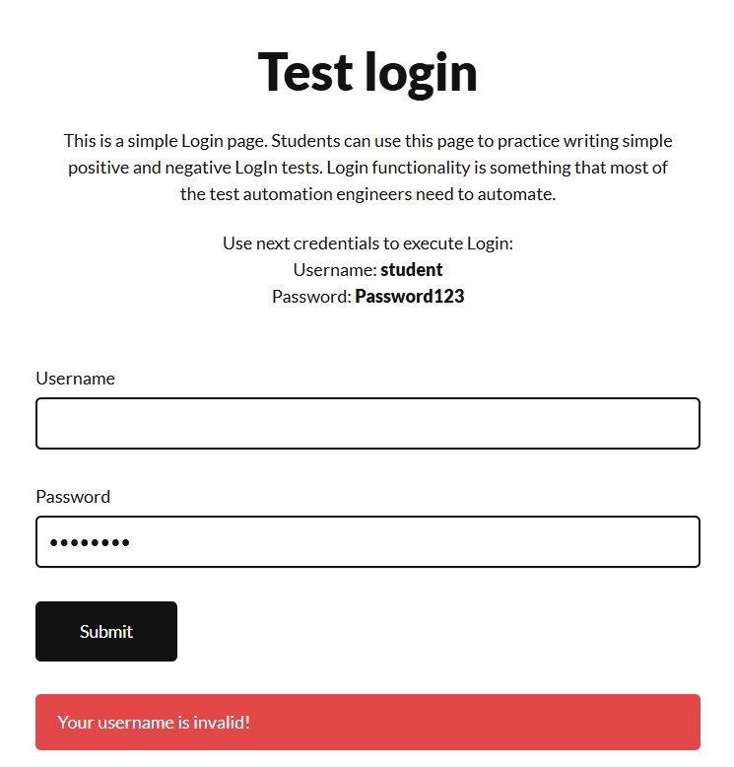

Step 3 — Invalid username error message (TC_AUTO_02)
Screenshot captured through Playwright Automation.
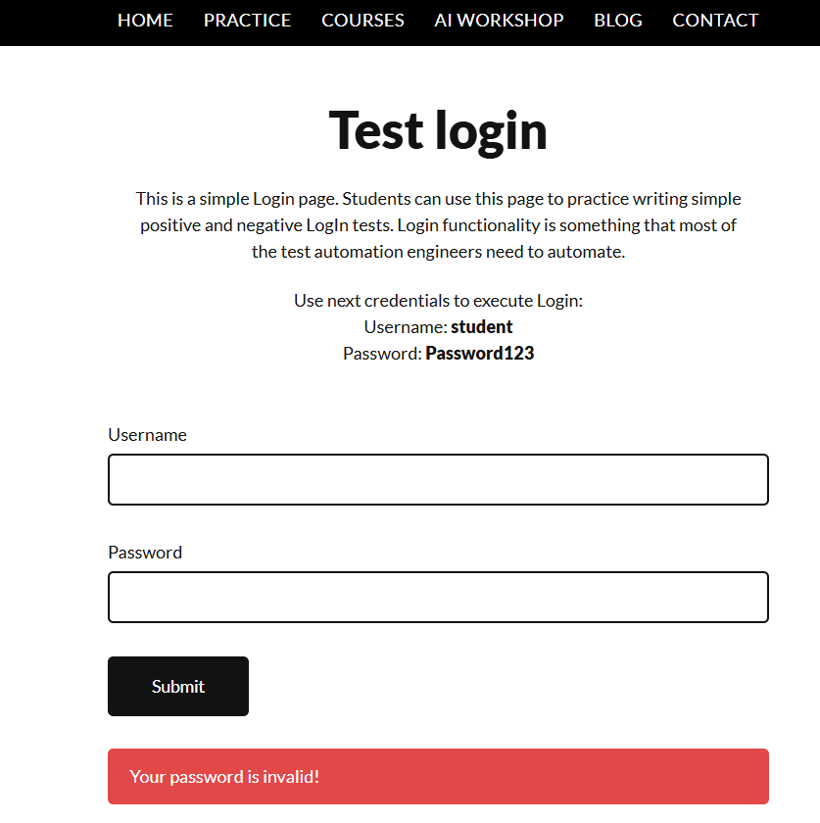

Step 4 — Invalid password error message (TC_AUTO_03)
Screenshot captured through Playwright Automation.
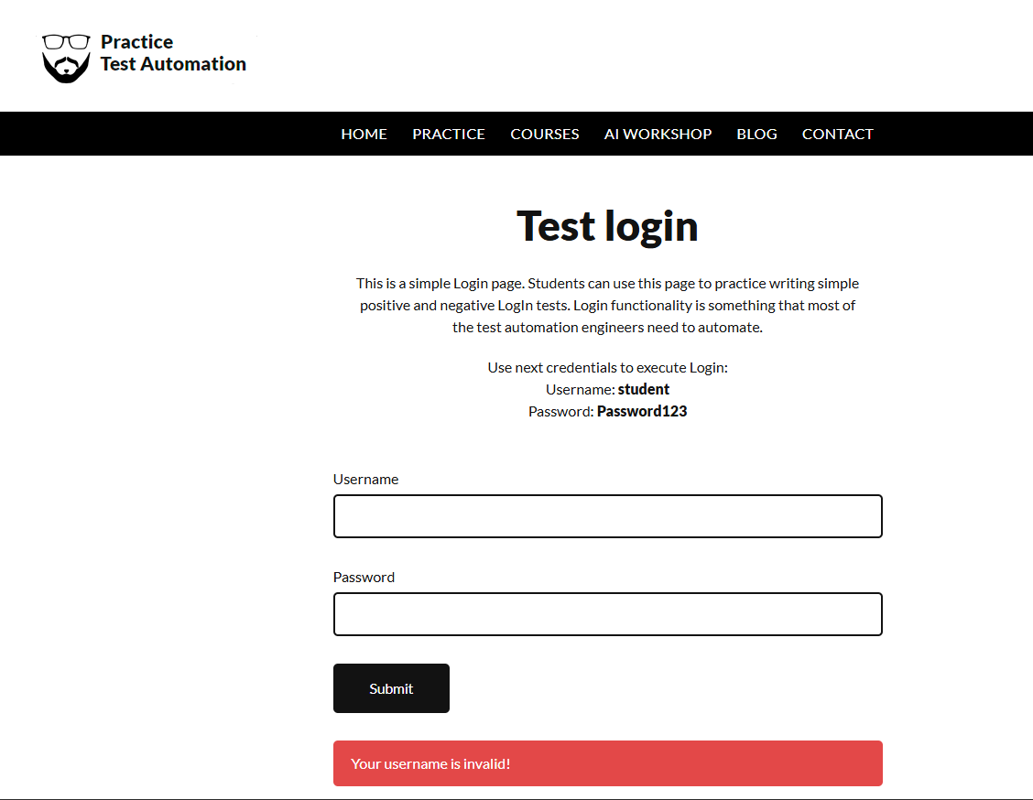
Step 5 — Blank-field validation, username checked first (TC_AUTO_04 / 05 / 06)
Screenshot captured through Playwright Automation.

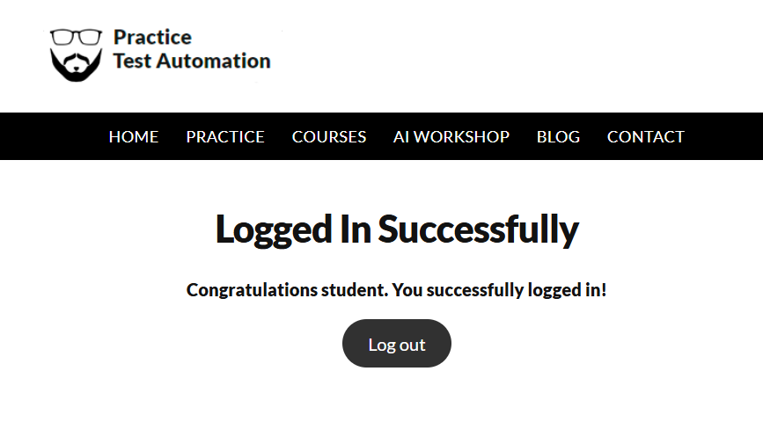

Step 6 — Logout redirect back to the login page (TC_AUTO_12)
Screenshot captured through Playwright Automation.

